Chapter 9 - Logistic Regression

**Challenger disaster, Part I.** (9.16, p. 380) On January 28, 1986, a routine launch was anticipated for the Challenger space shuttle. Seventy-three seconds into the flight, disaster happened: the shuttle broke apart, killing all seven crew members on board. An investigation into the cause of the disaster focused on a critical seal called an O-ring, and it is believed that damage to these O-rings during a shuttle launch may be related to the ambient temperature during the launch. The table below summarizes observational data on O-rings for 23 shuttle missions, where the mission order is based on the temperature at the time of the launch. *Temp* gives the temperature in Fahrenheit, *Damaged* represents the number of damaged O-rings, and *Undamaged* represents the number of O-rings that were not damaged.

|  |  |  |  |  |  |  |  |  |  |  |  |  |
| --- | --- | --- | --- | --- | --- | --- | --- | --- | --- | --- | --- | --- |
| Shuttle Mission | 1 | 2 | 3 | 4 | 5 | 6 | 7 | 8 | 9 | 10 | 11 | 12 |
| Temperature | 53 | 57 | 58 | 63 | 66 | 67 | 67 | 67 | 68 | 69 | 70 | 70 |
| Damaged | 5 | 1 | 1 | 1 | 0 | 0 | 0 | 0 | 0 | 0 | 1 | 0 |
| Undamaged | 1 | 5 | 5 | 5 | 6 | 6 | 6 | 6 | 6 | 6 | 5 | 6 |
|  |  |  |  |  |  |  |  |  |  |  |  |  |
| Shuttle Mission | 13 | 14 | 15 | 16 | 17 | 18 | 19 | 20 | 21 | 22 | 23 |  |
| Temperature | 70 | 70 | 72 | 73 | 75 | 75 | 76 | 76 | 78 | 79 | 81 |  |
| Damaged | 1 | 0 | 0 | 0 | 0 | 1 | 0 | 0 | 0 | 0 | 0 |  |
| Undamaged | 5 | 6 | 6 | 6 | 6 | 5 | 6 | 6 | 6 | 6 | 6 |  |

1. Each column of the table above represents a different shuttle mission. Examine these data and describe what you observe with respect to the relationship between temperatures and damaged O-rings.
2. Failures have been coded as 1 for a damaged O-ring and 0 for an undamaged O-ring, and a logistic regression model was fit to these data. A summary of this model is given below. Describe the key components of this summary table in words.

Estimate Std. Error z value Pr(*>|*z*|*) (Intercept) 11.6630 3.2963 3.54 0.0004

Temperature -0.2162 0.0532 -4.07 0.0000

1. Write out the logistic model using the point estimates of the model parameters.
2. Based on the model, do you think concerns regarding O-rings are justified? Explain.

**Answers**

1. As temperatures drop, the number of damaged O-Rings increases.
2. A low p-value indicates a statistically significant relationship between temperature and damaged O-rings. Since the lowest recorded temperature is 53, the intercept falls outside the plausible range for this data.
3. Logistic Equation is: Log (p/1 - p) = 11.6630 - 0.2162 × Temperature
4. The low p-value gives us valid reason to be concerned about the O-ring.

**Challenger disaster, Part II.** (9.18, p. 381) Exercise above introduced us to O-rings that were identified as a plausible explanation for the breakup of the Challenger space shuttle 73 seconds into takeoff in 1986. The investigation found that the ambient temperature at the time of the shuttle launch was closely related to the damage of O-rings, which are a critical component of the shuttle. See this earlier exercise if you would like to browse the original data.

50 55 60 65 70 75 80

Temperature (Fahrenheit)

Probability of damage

0.0 0.2 0.4 0.6 0.8 1.0

1. The data provided in the previous exercise are shown in the plot. The logistic model fit to these data may be written as

log 31 *p*ˆ 4 = 11*.*6630 *−* 0*.*2162 *× Temperature*

*− p*ˆ

where *p*ˆ is the model-estimated probability that an O-ring will become damaged. Use the model to calculate the probability that an O-ring will become damaged at each of the following ambient temperatures: 51, 53, and 55 degrees Fahrenheit. The model-estimated probabilities for several additional ambient temperatures are provided below, where subscripts indicate the temperature:

*p*ˆ57 = 0*.*341

*p*ˆ65 = 0*.*084

*p*ˆ59 = 0*.*251

*p*ˆ67 = 0*.*056

*p*ˆ61 = 0*.*179

*p*ˆ69 = 0*.*037

*p*ˆ63 = 0*.*124

*p*ˆ71 = 0*.*024

1. Add the model-estimated probabilities from part~(a) on the plot, then connect these dots using a smooth curve to represent the model-estimated probabilities.
2. Describe any concerns you may have regarding applying logistic regression in this application, and note any assumptions that are required to accept the model’s validity.

**Answer**

1. Here’s the equation with temperatures set to 51, 53, and 55 degrees Fahrenheit:

**For T = 51∘FT**

p(51) = e^(11.663−0.2126×51) / 1 + e^(11.663−0.2126×51) ≈ 0.6943

**For T = 53∘FT**

p(53) = e^(11.663−0.2126×53) / 1 + e^(11.663−0.2126×53) ≈ 0.5975

**For T = 55∘FT**

p(55) = e^(11.663−0.2126×55) / 1 + e^(11.663−0.2126×55) ≈ 0.4925

These values match your calculations:

p(51) ≈ 0.6943

p(53) ≈ 0.5975

p(55) ≈ 0.4925

where:

* p(T) represents the probability of O-ring damage at temperature T (in degrees Fahrenheit),
* e is the base of the natural logarithm,
* 11.663 and 0.21260 are coefficients from the model.

1. Here’s the equation explicitly set for the range of temperatures from 51 to 71 in increments of 2.  
   For each temperature T=51,53,55,…,71:  
   p(T) = e^(11.663−0.2162×T) / 1 + e^(11.663−0.2162×T)

So, for each specific temperature, the calculation would be:

**For T=51∘ FT**p(51) = e^(11.663−0.2162×51) / 1 + e^(11.663−0.2162×51)

**For T=53∘ FT**p(53) = e^(11.663−0.2162×53) / 1 + e^(11.663−0.2162×53)

**For T=55∘ FT**p(55) = e^(11.663−0.2162×55) / 1 + e^(11.663−0.2162×55)

And so on, continuing up to:

**For T=71∘FT**p(71) = e^(11.663−0.2162×71) / 1 + e^(11.663−0.2162×71)

This pattern applies for each T in the sequence 51,53,55,…,71in increments of 2.

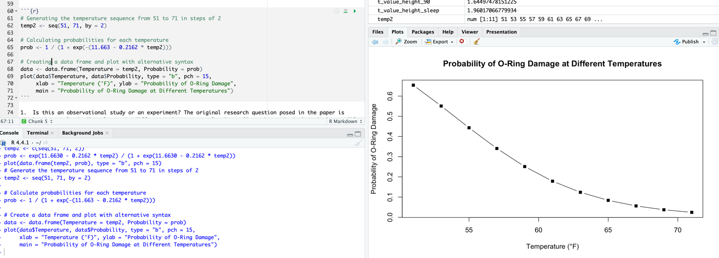

1. Assumptions: each observation is independent. It’s essential to account for all factors that could potentially contribute to O-ring damage.